What Should Our Business Produce?
Activity and performance assessment
Grade: 2-5
Targeted content: Conducting market research to decide what product to make for Market Day, using the basic economic concepts of wants and scarcity as guides.
Summary of performance assessment task: This is the first activity in a series in which students plan, design, build, and sell a good or service. In this activity, students conduct “market research” as to their peers’ wants. The activity also serves as a performance task. When students have completed the activity, they will have completed an important step in designing a real-world product to sell at Market Day, while demonstrating proficiency in the listed economics concepts and English writing skills.

Objectives (Virginia Standards of Learning):
Students will be able to
- Explain that scarcity (limited resources) requires people to make choices about producing and consuming goods and services. (History/Social Sciences 2.10)
- Explain that people make choices because they cannot have everything they want. (History/Social Sciences 1.8).

Students will also demonstrate skills for economic decision-making including
- Using a decision-making model to make informed decisions. (History/Social Sciences 3.1h)

Students will write for a variety of purposes by
- Using strategies for organization of information and elaboration according to the type of writing (by using the decision-making model). (English 3.9e)

Time required: 60 minutes

Materials needed:
- Student handout (below)

Literature to support and reinforce learning:
Arthur's Pet Business (Marc Brown, 1993): Brown Books for Young Readers.
- Economics mini-lesson for Arthur’s Pet Business here.

Some suggested lessons and resources to build prior knowledge: These lessons are optional. They are suggestions for how students can build knowledge of the economics objectives before beginning the assessment.
- “Would you like to be your own boss?” from the Mini-Economy Business Portfolio, www.vaminieconomy.org.
- “Toys for me: A lesson on choice” from EconEdLink. www.econedlink.org.
- Pp. 17-25 in Energy, Economics, and the Environment: Case Studies and Teaching Activities for Elementary School (Indiana Department of Education, 1994). For learning how to use a Decision Tree. Online sample here.
- “Open for Business!” from EconEdLink. www.econedlink.org.

Procedure
All student work is to be guided by the activity sheet below.
Students begin by rank-ordering and analyzing their own wants. They then survey their classmates (i.e. collect data) as to their wants.
At this point, the teacher should form the students into groups. These are the groups that they will stay in for the entirety of the Market Day project (see project materials). There are several ways to assign groups: the teacher can assign them, or allow students to choose. Alternately, the teacher can do the brainstorming activity (below) with the entire class, and assign groups based on students’ similarity of interests.
Next, groups of students brainstorm products that could serve to satisfy their classmates’ wants.
Finally, groups choose which product to make, guided by the Decision Tree.
The teacher can use the common analytic rubric provided with the Market Day resources to grade the student work.
A writing prompt is provided at the end to sum up student knowledge and to provide writing practice, if the teacher wishes to use it.

Instructional Modifications/Accommodations/Differentiated Instruction
- Student handout guides students through each step of the process
- Suggested lessons and literature provide visual and hands-on instructional support if the teacher chooses to use them
- Lesson plan allows for student choice in expressing economic wants, in brainstorming business ideas, and in choosing final business idea
- Student writing is aided by multiple pre-writing supports, including a list, categorization, a diagram, and a leading prompt
- Teacher can choose to assess student work based only on what is in the handout, and not on the written paragraphs

Hist/Soc Sci SOL 3.1h, K.9a, 1.8, 2.10; English SOL 3.9e

What Should Our Business Produce? (Teacher copy)
In this activity, you and your group will decide what to produce in your Mini-Economy business. You will use your knowledge of wants, scarcity, organizing information, and using decision-making models to complete the task.
Define the following economics vocabulary words:
Want:
[Example]: Something that makes me feel good, [or] that fulfills a desire, [or] that brings a benefit.
Scarcity:
[Example]: Scarcity is when I can’t fulfill all of my wants
Next, list six wants that you have. They must be wants that you can somewhat control with your choices.
Then, rank them in order of how important they are to you.
Want Rank
[Examples]: A vacation 5
A video game system 3
My friends to stop fighting about things 1
A lot of candy bars 6
To play more soccer 2
To not be bored after school 4

Next, pretend that you only get to consume three of the wants on your list, and you have to give up the other three. Put a check mark next to each want that you would choose.
Complete this sentence: “Scarcity affects my wants by [Example]: making me decide which of my wants I want the most, and then making a choice!

Next, you will go around the room and ask your classmates what wants they wrote down. They will ask you, too. Then try to think of goods and services that you could produce that might satisfy their wants.
Pick three things that you could produce to satisfy your classmates’ wants.
- I can produce… [Examples]: toucan masks

to satisfy this want: Wanting to be not bored after school .

Is this a good or a service? A good [because it is a tangible object].

- I can also produce… A hair-braiding business

to satisfy this want: Want to look nice; want to have more fun at school.

Is this a good or a service? Service

- I can also produce… A problem-solving business

to satisfy this want: Want people to stop getting into arguments about what to do at recess.

Is this a good or a service? A service
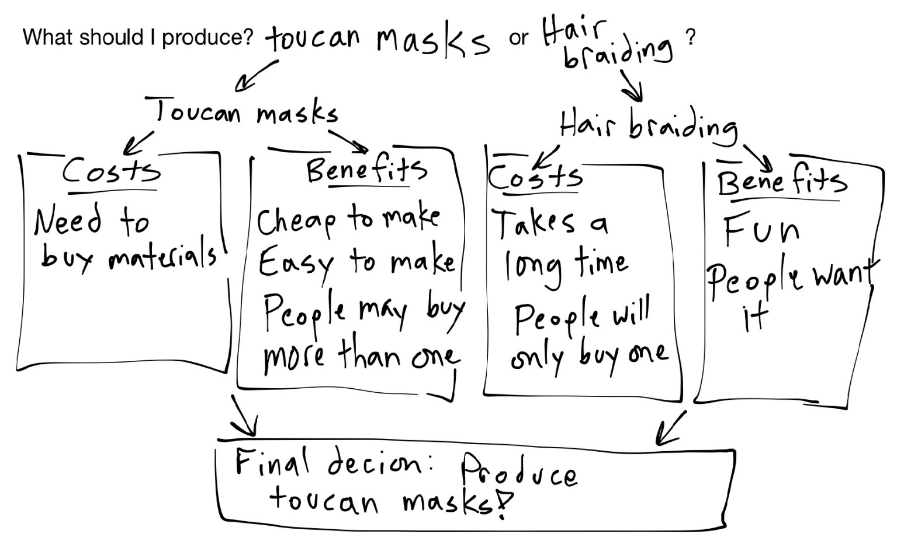
Choose two of the goods/services above. Use a decision-making model to weigh the costs and benefits of producing that good or service. You will present your final decision to your group=mates

Name _____________________________________________
What Should Our Business Produce?
In this activity, you and your group will decide what to produce for your Mini-Economy business. You will use your knowledge of wants, scarcity, organizing information, and using decision-making models to complete the task.
Define the following economics vocabulary words:
Want:

Scarcity:

Next, list six wants that you have.
Then, rank them in order of how important they are to you.
Want Rank
________________________________________________ ______________

________________________________________________ ______________

________________________________________________ ______________

________________________________________________ ______________

________________________________________________ ______________

________________________________________________ ______________

Next, pretend that you only get to consume three of the wants on your list, and you have to give up the other three. Put a check mark next to each want that you would choose.
Complete this sentence: “Scarcity affects my wants by ___________________________________________

________________________________________________________________________________________

________________________________________________________________________________________

Next, you will go around the room and ask your classmates what wants they wrote down. They will ask you, too. Then try to think of goods and services that you could produce that might satisfy their wants.
Pick three things that you could produce to satisfy your classmates’ wants.
I can produce… ______________________________________________________________________________________

to satisfy this want: ______________________________________________________________________ .

Is this a good or a service? _________________

I can also produce… ___________________________________________________________________________________

to satisfy this want: ______________________________________________________________________.

Is this a good or a service? _________________

I can also produce… ___________________________________________________________________________________

to satisfy this want: ______________________________________________________________________.

Is this a good or a service? _________________

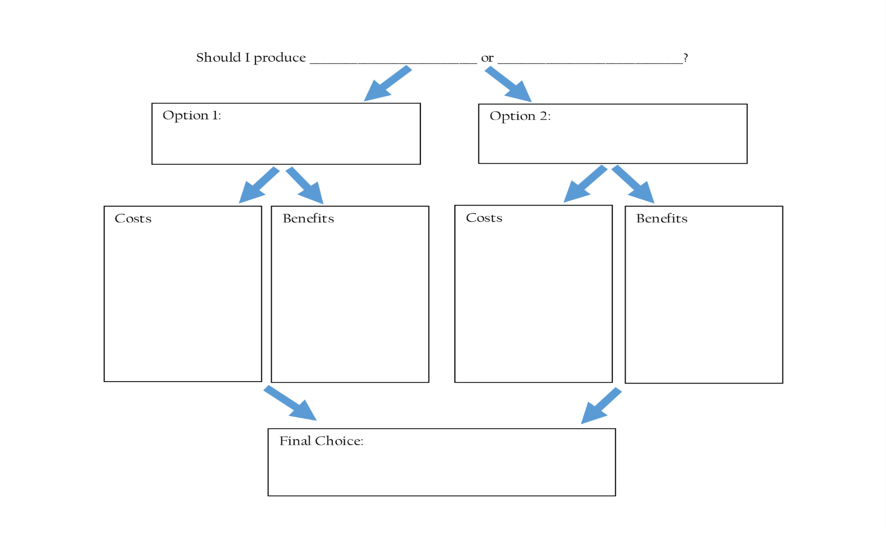
Choose two of the goods/services above. Use a decision-making model to weigh the costs and benefits of producing that good or service. You will present your final decision to your group=mates to consider.
Write a short paragraph that answers the following prompts:
- In this activity, how did the ideas of wants and scarcity help you decide what your business should produce?

- How did this activity help you understand what it takes to be a successful entrepreneur?

