What Should I Specialize In?
Activity and performance assessment
Grade: 2-5
Targeted Content: Using data from a classroom experiment to evaluate the use of specialization in students’ classroom businesses.
Summary of performance assessment task: In this task, students decide whether they should modify their Market Day business’s production processes using the economic concept of specialization.
Objectives (Virginia Standards of Learning):
Students will be able to:
- Recognize that because people and regions cannot produce everything they want, they specialize in what they do best and trade for the rest. (History/Social Sciences 3.9)
- Identify examples of making an economic choice and will explain the idea of opportunity cost (what is given up when making a choice). (History/Social Sciences 3.10)
Students will write for a variety of purposes by:
- Using strategies for organization of information and elaboration according to the type of writing. (In this case, by pre-writing answers to support the main point, and by creating a production diagram). (English 3.9e)
Time required: 60 minutes (including supporting material, i.e. an assembly line simulation)

Materials needed:
- Student handout (below)
- Materials for a classroom assembly line. We recommend play-doh. See lesson suggestions below.

Literature to support and reinforce learning:
A Busy Day at the Factory, (Philippe Dupasquier, 1994). Candlewick Press.
It Takes a Village, (Jane Cowen-Fletcher, 1994). Scholastic.
.
Some suggested lessons and resources to build prior knowledge: For this performance assessment, it is necessary to prepare students by conducting a classroom activity in which students compare two different types of ways to produce something. Here are some options:
- “Specialization” in Playful Economics (2011). Council for Economic Education.
- “Assembly Line Simulations,” by Scholastic. www.scholastic.com.

Other helpful lessons include:
- “Lean on Me: We Depend on Each Other,” on EconEdLink. www.econedlink.org.
- “Why Do Most People Have a Job Where They Only Make One Good or Service?” on VA Mini-Economy. www.vaminieconomy.org.

Procedure
Students begin by gathering data by doing a classroom experiment. In the experiment, students test which method of production is most effective for making Play-Doh hamburgers: an assembly line, or simply having each student make their own burgers. This experiment is described in the lesson plan entitled “Specialization” in the book Playful Economics (Council for Economic Education). A similar lesson can be found free and online at http://www.scholastic.com/teachers/top-teaching/2016/01/assembly-line-simulations
Students form two groups: a “craftsman” group in which each student makes his or her own burger, and the assembly line group, in which each student has a specialized job. The teacher provides each group with the same amount of “capital resources” (pencil, ruler), and gives the groups a certain amount of time to product.
The class then debriefs the activity, and then students meet in their Market Day business groups to evaluate the usefulness of an assembly line or some other form a specialization for their business.
Students record their answers to their business-specific questions in the accompanying activity sheet.
Finally, students create a diagram of their businesses’ production practices.
The teacher can grade the activity sheet and production diagram using rubric provided in the Mini-Economy Business Portfolio materials (www.vaminieconomy.org).

SOL K.8, 1.8, 2.8, 2.10, 3.9, 3.10; English SOL 3.9
What Should I Specialize In? (Teacher copy)
In this task, you will decide how to organize your business. Some ways may be better than others! You will use your knowledge of specialization, productive resources, and organizing information to complete this task.
Define specialization:
Specialization is when people focus on doing what others’ don’t have the time to do. Or: Specialization is when people focus using their resources in the best possible way. Or: Specialization is when people focus on producing what they do best.
In our business, my special job is (write your job title as well as the work you do):
Example: I am the Hair-Braider. I am the one that puts the braids in customer’s hair.

I specialize in this because:
[Example]: I have the special skill of hair-braiding that not all of my partners have.
The jobs my business partners have are (job title and work they do):
1. Advertiser: Olivia decides what our ads will look like and makes them
2. Economist: Keyana does research on market prices and decides if we should change our own prices
3. Hair-braider #2: Maya also braids hair, because she is the other one in our group that is really good at it
What is your opportunity cost of doing this job?
My second choice would be to do research on prices like Keyana does, but I don’t have time because I’m braiding hair. (But at least she gives us some say-so in price decisions.)
How does specialization help your team produce your good/service? Is there any way that specialization does not help you? (Your answer must show that you know what specialization is.)
When we first started our business we didn’t specialize as much. But after the lesson on specialization we tried it. It made things less confusing. Everyone was able to focus on their special job. It also allowed us each to be the boss of something, which feels good.

Draw a diagram of your production process. Show the natural resources, human resources (including each group partner), and capital resources that you use, as well as the finished product. Be sure to include everything!
Example of a production diagram: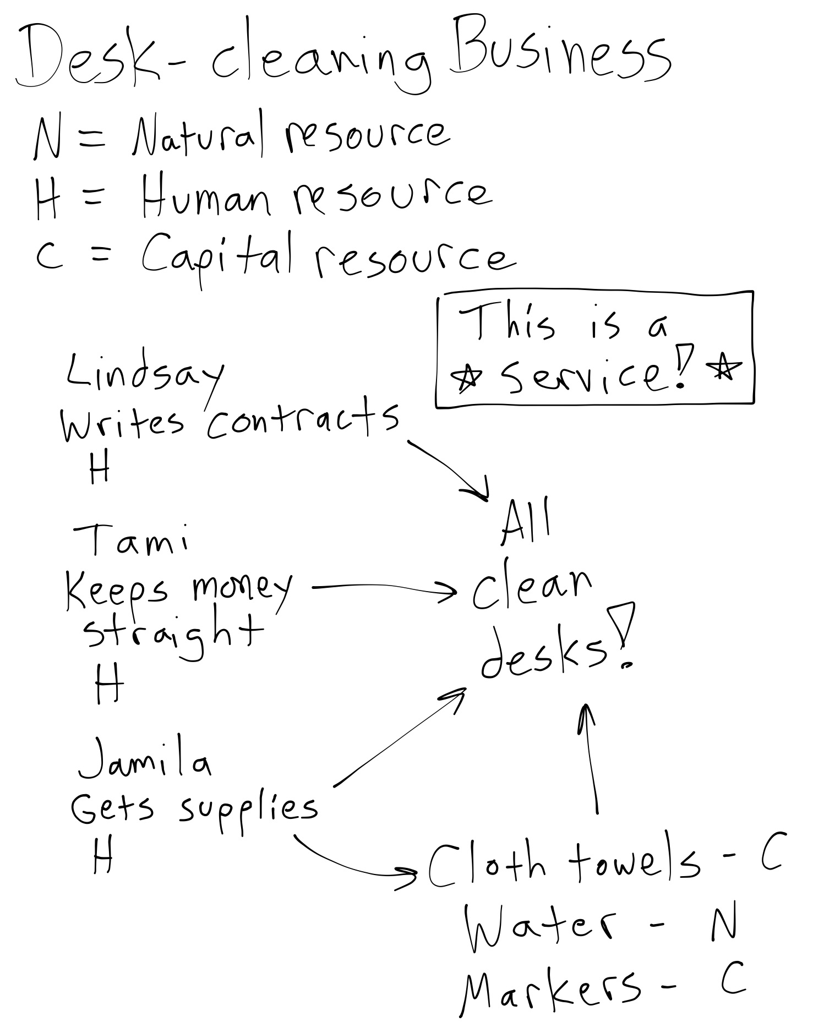
Bonus: Ask a grown-up what he or she specializes in at work!
Name: ________________________________________
What Should I Specialize In?
In this task, you will decide how to organize your business. Some ways may be better than others! You will use your knowledge of specialization, productive resources, and organizing information to complete this task.
Define specialization:

In our business, my special job is (write your job title as well as the work you do):
Example: I am the Hair-Braider. I am the one that puts the braids in customer’s hair.

I specialize in this because:

The jobs my business partners have are (job title and work they do):
1.
2.
3.
What is your opportunity cost of doing this job?

How does specialization help your team produce your good/service? Is there any way that specialization does not help you? (Your answer must show that you know what specialization is.)

Draw a diagram of your production process. Show the natural resources, human resources (including each group partner), and capital resources that you use, as well as the finished product. Be sure to include everything!

Bonus: Ask a grown-up what he or she specializes in at work!

Example of a production diagram:

